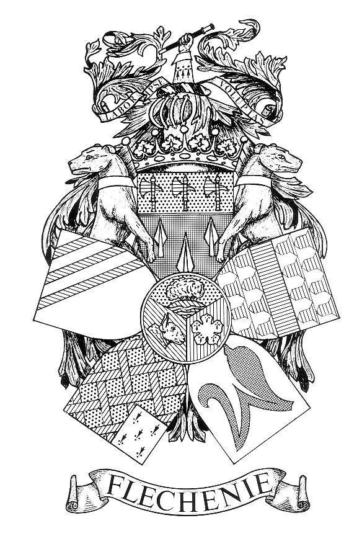 NOTICE OF PARISH COUNCIL MEETING

PARISH OF FLECKNEY

I hereby give notice that a Parish Council Meeting of the Parish Council of the above named Parish will be held at the Sports Centre on Monday 13th February 2023
at 7.00 pm.

All members of the Council are hereby summoned to attend for the purpose of considering and resolving the business to be transacted at the Meeting as set out hereunder.

John Flower
Clerk to the Council
Dated 30 July 2026

AGENDA
- Apologies for Absence.

- Declarations of Interest.
To receive declarations of interest under the Code of Conduct in respect of items on the agenda.

- Dispensation Requests
To receive and approve requests for dispensations from members on matters in which they have a Disclosable Pecuniary Interest.

- Public Participation. (Limited to 15 minutes. The Chairman will adjourn the Meeting during the period of Public Participation).To allow members of the public the opportunity to make representations, ask questions or give evidence about any item of business on the agenda of the Meeting limited to three minutes per person (or one person on behalf of a group of people) about any single item of business.

- Minutes.
To approve and sign the Minutes of the Meeting held on the 9th January 2023
(Enclosure A).

- Matters Arising.
To consider any matters arising from the Minutes of the Meeting held on 9th January 2023. (Matters of report only).

- Accounts.
To receive and approve:
    - Schedule of amounts for payment (Enclosure B1 to follow)
    - Schedule of receipts for January 2023. (Enclosure B2 to follow)
    - Bank reconciliation report at 31st January 2023. (Enclosure B3 to follow)
    - Details of Petty Cash payments for the December quarter. (Enclosure B4 to follow)

- District and County Councillors’ and Police Reports.
    - To receive reports.
    - To receive details of the latest crime statistics for the Village. (Enclosure C to follow).

- Correspondence
To receive details of correspondence received since the last Meeting.

- Employees and Chairman’s Reports.
(i) To receive the report of the Street Orderly. (Enclosure D to follow).
- To receive the report of the Chairman.

- Recreation Committee.
To receive the minutes of the Recreation Committee that met on 30th January 2023 (Enclosure E to follow)

- Planning Applications.
To consider and comment on planning applications received since the last meeting. (Enclosure F).
,
- Village Centre Improvements.
In the context of the £50k funding made available by Harborough DC for Village Centre improvements from its UK Shared Prosperity Fund allocation to consider suitable projects that would improve and enhance the Village Centre.

- Bowls Club Lease.
To consider if the Hart of Fleckney Bowls Club should be required to contribute towards the Council’s legal costs involved in surrendering the existing lease (due to expire in 2028) and entering into a new lease.

- Grant Application.
To consider a request for a grant from the 1st Fleckney Guides to help support financially its forthcoming camping trip.

- Standing Orders.
To review and consider revisions to the Parish Council’s Standing Orders. (Enclosure G)

- VAT on Sports and Leisure Services.
To consider the implications of the decision by HMRC, following its unsuccessful appeal in the Chelmsford City Council case, that local authority sport and leisure services can be treated as non-business and outside the scope of VAT.

- Appointment of Internal Auditor.
    - To agree to the appointment of LRALC (Caroline Camp) to carry out the internal audit for the financial year 2022-23.

    - To authorise the Clerk to issue a letter of engagement.

- New Sports Centre – Next Steps.
To receive a report on the meeting held with Ball Hall (Project Management) Ltd on 7th February 2023 and to consider any action arising there from.

- Date of Next Meeting.
Monday 13th March 2023 at 7.00pm

Members of the public are welcome to attend but are not permitted to participate except under Item 4 when invited to do so by the Chairman after the Meeting has been adjourned

