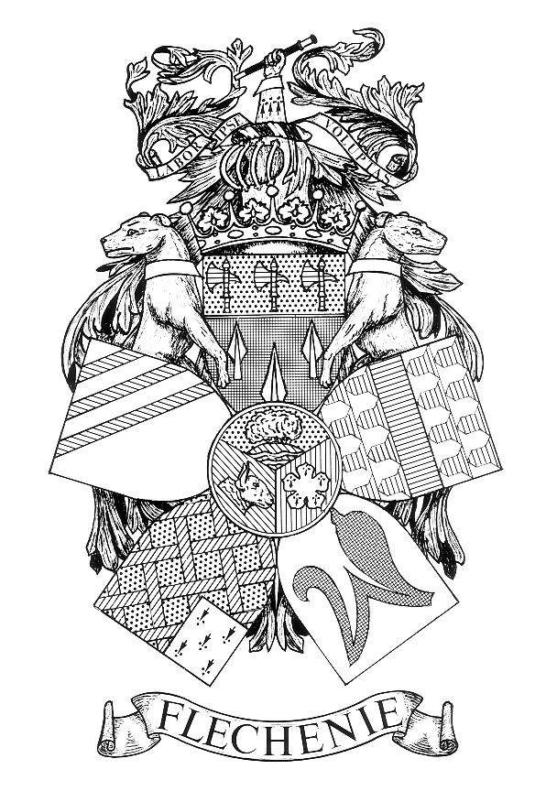 NOTICE OF PARISH COUNCIL MEETING

PARISH OF FLECKNEY

I hereby give notice that a Parish Council Meeting of the Parish Council of the above named Parish will be held at the Fleckney Sports Centre on Monday 10th June 2024 at 7pm.

All members of the Council are hereby summoned to attend for the purpose of considering and resolving the business to be transacted at the Meeting as set out hereunder.

Helen Denton- Stacey
Clerk to the Council
Dated 30 July 2026

AGENDA
- Apologies for Absence.

- Declarations of Interest.
To receive declarations of interest under the Code of Conduct in respect of items on the agenda.

- Dispensation Requests
To receive and approve requests for dispensations from members on matters in which they have a Disclosable Pecuniary Interest.

- Public Participation. (Limited to 15 minutes. The Chairman will adjourn the Meeting during the period of Public Participation).To allow members of the public the opportunity to make representations, ask questions or give evidence about any item of business on the agenda of the Meeting limited to three minutes per person (or one person on behalf of a group of people) about any single item of business.

- Minutes.
To approve and sign the Minutes of the Meeting held on the 13th May 2024.
(Enclosure A).

- Matters Arising.
To consider any matters arising from the Minutes of the Meeting held on 13th May 2024. (Matters of report only).

- Accounts.
To receive and approve:
    - Schedule of amounts for payment (Enclosure B1 to follow)
    - Schedule of receipts for May 2024. (Enclosure B2 to follow)
    - Bank reconciliation report at 31st May 2024. (Enclosure B3 to follow)

- Internal Auditor’s Report 2023-24.
To receive the report of the Internal Auditor. (Enclosure C).

- Accounts and Annual Return for the Year Ending 31st March 2024.
  - To receive the Statement of Income and Expenditure for the Year Ended 31st March 2024 and Balance Sheet as at 31st March 2024. (Enclosure D).

  - To consider and approve the Annual Governance Statement 2023/24.
(Enclosure E).

  - To consider and approve the Accounting Statement 2023/24. (Enclosure F).

- District and County Councillors’ and Police Reports.
    - To receive reports.
    - To receive details of the latest crime statistics for the Village. (Enclosure G to follow).

- Correspondence
To receive details of correspondence received since the last Meeting.

- Employees and Chairman’s Reports.
(i) To receive the report of the Street Orderly. (Enclosure H to follow).
- To receive the report of the Chairman.

- Sports Centre Update.
    - To receive update on the meeting held with Ball Hall 3rd June 2024

- Planning Applications.
To consider and comment on planning applications received since the last meeting. (Enclosure I).
,

- Lodge Farm Solar Park.
The Clerk to provide information on the proposed Local Community Benefit Fund to be administered through Kilby, Wistow, and Fleckney Parish councils which was referred to by Elgin Energy during the consultation process.

- Events
Fleckney Festival & D Day

- Date of Next Meeting.
Monday 8th July 2024 at 7.00pm

Members of the public are welcome to attend but are not permitted to participate except under Item 4 when invited to do so by the Chairman after the Meeting has been adjourned

