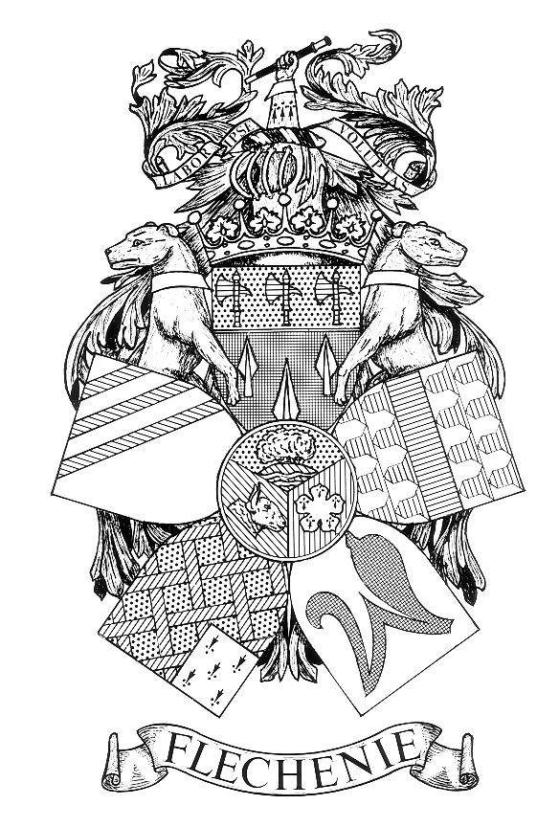 NOTICE OF MEETING

FLECKNEY PARISH COUNCIL

I hereby give notice that a meeting of the Parish Council (Playing Field Charity) will be held at the Sports Centre, Leicester Road on Monday 11th January 2021 at the conclusion of the Meeting of the Parish Council.
This will be a virtual meeting held in accordance with the Local Authorities and Police and Crime Panels (Coronavirus) (Flexibility of Local Authority and Police and Crime Panels Meetings) (England and Wales) Regulations 2020.
Join Zoom Meeting
https://us02web.zoom.us/j/81030817873?pwd=N1hmZjdaWVBvWHMxaDN3M3ZOREVsZz09

Meeting ID: 810 3081 7873
Passcode: 379917

One tap mobile:
By telephone: +44 203 481 5240
+44 131 460 1196
+44 203 051 2874
+44 203 481 5237

All members of the Council are hereby summoned to attend for the purpose of considering and resolving the business to be transacted at the Meeting as set out hereunder.

John Flower
Clerk to the Council
Dated 29 July 2026
AGENDA
- Apologies for Absence.

- Declarations of Interest.
To receive declarations of interest under the Code of Conduct in respect of items on the agenda.

- Requests for Dispensations.
To receive and approve requests for dispensations from members on matters in which they have a Disclosable Pecuniary Interest.

- Public Participation. (Limited to 15 minutes. The Chairman will adjourn the Meeting during the period of Public Participation).
To allow members of the public the opportunity to make representations, ask questions or give evidence about any item of business on the agenda of the Meeting limited to three minutes per person (or one person on behalf of a group of people) about any single item of business.

- Minutes.
To approve the Minutes of the Meeting held on the 7th October 2019. (Enclosure A).

- Matters Arising.
To consider any matters arising from the Minutes of the Meetings held on 7th October 2019. (Matters of report only).

- Correspondence.
To receive details of correspondence received.

- Legacy Entitlement.
The Clerk to report the notification of an anonymous legacy equal to 4.5% of the residue of an estate to be shared between the Playing Field Charity and two other Fleckney charities.

- Grass Pitch Improvement Funding Agreement.
To consider the recommendation of the Recreation Committee that an Agreement is entered with Fleckney Athletic AFC to allow the Club to carry out maintenance work to the football pitches over a ten year period. (Enclosure B to follow).

- Agreement with Parish Council for Maintenance of Charity Land.
To consider entering into an Agreement with the Fleckney Parish Council for the maintenance of the Charity land for the period from 1st April 2021. (Enclosure C to follow).

- Bank Account Signatories.
To approve a new signatory to replace Lesley McKemey on the Charity’s bank account with NatWest Plc.

- Date of Next Meeting.

