MISSION STATEMENT
To provide leadership and vision and by working together with others,
to make Fleckney a better place to live, work, study or visit.

FLECKNEY PARISH COUNCIL

ANNUAL REPORT 2020-21

The Annual Report is an opportunity to inform residents of what has happened over the last year, what has been achieved and to look forward to the future. The last year has been overshadowed by the Covid-19 pandemic which has impacted on everyone in some way. The resumption to some form of normality in the near future will be a welcome relief and will enable the Parish Council to once again effectively provide for the needs of the local community.

Who are your parish councillors and how do you get in touch with them:

Parish Councillors | Contact Information
Cllr. Suzanne Wyche (Chairman) | 07801 768482 suzanne.wyche@gmail.com
Cllr. Alan Birch (Vice Chairman) | 0116 240 3506 billbirch@btinternet.com
Cllr. Jamie Brummel | 0116 240 2366 jamie.brummell@homeserve.com
Cllr. Janet Earwaker | 0116 240 2993 janearwaker@yahoo.co.uk
Cllr. Tina Mcdonagh | 0116 240 2275 t.mcdonagh@btconnect.com
Cllr. Charlie McKemey | 0116 240 2184 charliemckemey@hotmail.com
Cllr. Steven Parker | 0116 240 3511 stevenjparker@aol.com
Cllr. Stephen Robson | 0116 240 3218 stevearobson@hotmail.co.uk
Cllr. Callum Ward | cward@stconsult.co.uk
Who are the Parish Council employees:

The Council employs a Clerk to the Council (P/T), Facilities Manager/Sports Development Officer (F/T) and also on a part-time basis, two Premises Officers, a Relief Premises Officer, a Street Orderly, a Grounds Maintenance Operative and an Administrative Assistant.

A message from the Chairman:
It goes without saying that this has been a difficult year for so many people. However, it has been wonderful to see the Fleckney community come together to continue to support its residents throughout this difficult period. Many voluntary groups have found ways to continue the work they do and new voluntary groups were set up to respond to additional needs raised by the pandemic.

The Parish Council were unable to meet in person between March 2020 and May 2021 but instead carried out meetings virtually, enabling their work on behalf of the village to continue.

There are two key pieces of work that I would like to update you on. Firstly, as reported in the Communicata, the Fleckney Neighbourhood Plan was approved by Fleckney residents through a public referendum on May 6th and subsequently formally approved by Harborough District Council, our local planning authority. An approved Neighbourhood Plan is the village’s voice in shaping development within the village when Harborough District Council are determining planning applications and it carries significant weight in the decision-making process. Having a Neighbourhood Plan is a valuable improvement on previous years when we have been subjected to significant less controlled development in the village. My thanks to the Parish Council members, volunteers and staff who worked hard to bring this plan into effect.
Secondly, progress has been made towards the build of the new sports centre. New facilities, including a gym and other requirements have been documented, a provider has been identified and the first designs have been created. Next steps are to finalise the designs, source funding and then confirm a start date. The new sports centre is an exciting opportunity to provide enhanced sports facilities for the growing village and we welcome volunteers to help shape the outcome. If you have time or skills that would be useful to the project please contact us through the usual channels contained in this report.
In addition to the above, the Parish Council has made improvements at the village green in the form of a village sign and a viewing platform and we continue to work towards making the village roads safer by purchasing speed signs, which are due to be installed shortly.

The Parish Council is made up of a group of volunteers who make decisions on behalf of the village as the lowest tier of local government. In Fleckney we have a budget of approximately £200,000 per annum that comes from a proportion of the council tax, fees for use of the Sports Centre and other facilities and grants. This income is used to maintain existing facilities and provide enhancements to the village. Currently there are nine parish councillors and therefore four seats available on the Parish Council should anyone want to join us.
The Council is responsible for managing the Sports Centre and the Leicester Road and Lodge Road recreation grounds. Other duties include keeping the village free of litter, providing dog bins and allotments, responding to formal consultations and representing the village in relation to planning applications and highways matters.
Finally, I’d like to thank my fellow councillors who give their time freely for the benefit of Fleckney, the parish council staff who work hard on behalf of the village and all the volunteers who work tirelessly for the many and varied voluntary organisations within the village, which contribute to maintaining its strong sense of community.
Suzanne Wyche
Chairman.

What are our key objectives?

1. To provide opportunities for participation in recreation, sport, leisure, social and educational activities. | 5. To support the provision of sustainable and affordable public transport.
2. To help achieve a healthy and active population. | 6. To support the provision of sustainable and affordable local housing.
3. To help in the reduction in crime and anti-social behaviour. | 7. To ensure the local natural and built environment continues to reflect the rural nature of the Village and the surrounding landscape.
4. To help provide an enhanced and sustainable local economy and services. | 8. Actively promote local democracy, accountability, community involvement and participation.

A – Z of Achievements:

- Allotments – Hedge and tree works carried out at the Leicester Road site.
- All Weather Pitch – New football goals added.
- Annual Report – Produced and sent out to all households in the village.
- Audit of Accounts - Received an unqualified opinion on the 2019-20 Annual Governance and Accounting statements highlighting our commitment to good governance and financial practices.
- Community Orchard – Planted some additional fruit trees at the Leicester Road Recreation Ground.
- Community Safety Priorities – Established local priorities for the Community Safety Partnership.
- Dog Bins – Provided at various locations throughout the village.
- Exercise Classes – Additional exercise classes provided for pre-school and primary aged children.
- Grants – Successful in obtaining grants for All Weather Pitch goals and to mitigate the impact of the loss of income due to Covid -19.
- Holiday Scheme - Provided a limited number of holiday and sport related children's holiday schemes during the year.
- Litter – A Street Orderly employed to pick litter in the village centre and surrounding streets.
- Meetings – Council and committee meetings held via Zoom due to the restrictions on face-to-face meetings.
- Neighbourhood Plan – The Fleckney Neighbourhood Plan received a resounding YES vote in the referendum held on 6th May 2021. The policies in the Plan are now a statutory part of the planning process and will need to be taken into account when decisions on planning applications in Fleckney are taken by the planning authority.
- New Activities – Include Superstar Football, Kung Fu Tigers, Urban Kickboxing and Buggy Fitness.
- New Sports Centre Building – Further work carried out on the design and consultants appointed to conduct pre-planning application discussions with Harborough DC to establish its feasibility in terms of the planning requirements. A topographical survey carried out to establish levels.
- Notice Board – New notice board provided at the Library.
- Parish Councillors – It was with great sadness that we lost the services of Lesley McKemey during the year. Currently there are four vacant seats.
- Planning Applications - Commented on planning applications as a statutory consultee and objected to a number where the development was felt inappropriate for the village.
- Priest Meadow Open Space – Maintained area pending a long term solution being found with the owner.
- Public Participation - Allowed members of the public to speak at parish council meetings by providing a “public participation” item on all agendas.
- Reserves – Monies set aside for the replacement of the All Weather Pitch playing surface and towards the cost of a new Sports Centre.
- Section 106 Agreements – Greater flexibility being sought through Harborough DC on how the monies obtained to mitigate the impact of housing development in the Village can be spent.
- Sports Centre – Limited usage during the year due to closures brought about by the Covid-19 pandemic. The facility was closed April to July 2020, November 2020 and January to March 2021.
- Support for Local Voluntary Organisations – Provided grants to Fleckney Village Aid Scheme, British Legion, Fleckney School, Harborough DC Chairman’s Charity and Leicester Hospitals Charity.
- Vehicle Activated Speed Sign – Mobile sign operational at four sites. New fixed signs to be installed on Saddington Road and Leicester Road.
- Village Green and Duck Pond – Viewing platform, duck house and pond fountain provided to the Village Pond. Village sign and display board provided on the Village Green. Additional funding being sought to provide feature lighting to the Village Pond. Purchase of Village Green and Duck Pond from Harborough DC being pursued now that the Neighbourhood Plan has been finalised.
- Website – Sports Centre website further developed and social media being used more extensively to advertise activities and provide news.
- Wild Flower Verge – Further seeding has taken place to the wild flower verge created on Saddington Road at its junction with The Meer due to the damage caused by contractors working on the site.
- Youth Club – Discussions ongoing with Harborough District Children and Young People’s Charity on the provision of a youth club facility in the Village.

Precept and Council Tax 2021-22:

The Parish Council at its meeting on 11th January 2021 agreed keep the precept for 2021-22 at its 2020-21 level of £143,150. This amount will be paid by Harborough District Council in two instalments to the Parish during the year and will be collected from residents in the village as part of their Council Tax bill. The amount for a Band D property for parish purposes will be £90.30, an increase of £0.55 or 0.6%.

Overall, the Parish Council has budgeted to spend £290,800 in 2021/22 and is anticipating receiving £211,150 in income from the Precept, grants & contributions and charges for services and facilities. Full details of the budget for 2021-22 and the final accounting statements for 2020-21 can be viewed on the Council's website.

Summary of Accounts 2020-21:

Year Ended 31st March 2020 | Income and Expenditure Account | Year Ended 31st March 2021
£ | Income | £
47,826.23 | Fees and Charges | 31,649.95
-1,686.67 | Grants and Contributions | 4,671.67
400.00 | Rents | 433.45
135,050.00 | Precept | 143,150.00
£181,589.56 | Total Income | £179,905.07
 | Expenditure
32,588.02 | Administration | 31,637.09
700.00 | Members Expenses | 300.00
100,920.77 | Provision of Services | 94,845.96
10,758.63 | Loan Repayments | 7824.70
10,039.37 | Capital Expenditure | 17,054.34
£155,006.79 | Total Expenditure | £151,662.09
Year Ended 31st March 2020 | General Fund | Year Ended 31st March 2021
233,829.47 | Balance B/Fwd 1st April | 150,412.24
26,582.77 | Surplus during the year | 28,242.98
-110,000.00 | Transfer to Earmarked Reserve | -60,000.00
£150,412.24 | Balance at 31st March | £118,655.22
 | Earmarked Reserves
30,000.00 | All Weather Pitch Surface Replacement | 40,000.00
100,000.00 | New Sports Centre Building | 150,000.00
£130,000.00 |  | £190,000.00

Here’s how we let you know what we are doing:

- Articles in the Communicata
- 'Facebook and Twitter
- Providing websites for the Parish Council, Sports Centre and Neighbourhood Plan
- Having meetings that are open to the public
- Providing Parish Council notice boards. The boards are available for display of Parish Council and community information (not commercial). To advertise an event, activity, etc., please drop posters (maximum size A4) into the Sports Centre, Leicester Road, LE8 8BG.

How to get in touch:
Postal Address Fleckney Parish Council, PO Box 8092, Fleckney, Leicester LE8 8WW.
Telephone Parish Council: 0116 2404589 Sports Centre: 0116 2403755
Websites Parish Council: www.fleckneyparishcouncil.org.uk
Sports Centre: https://www.hugofox.com/community/fleckney-sports-centre-14927/home
Neighbourhood Plan: www.fleckneynp.org.uk
Twitter Parish Council: @fleckneyparishc Sports Centre: @Fleckneysports
Facebook Parish Council: www.facebook.com/fleckneyparishcouncil
Sports Centre: www.facebook.com/Fleckneysportscentre

For opening times for the Parish Council Office and the Sports Centre visit the website: www.fleckneyparishcouncil.org.uk

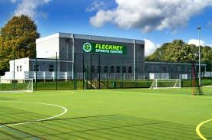 | 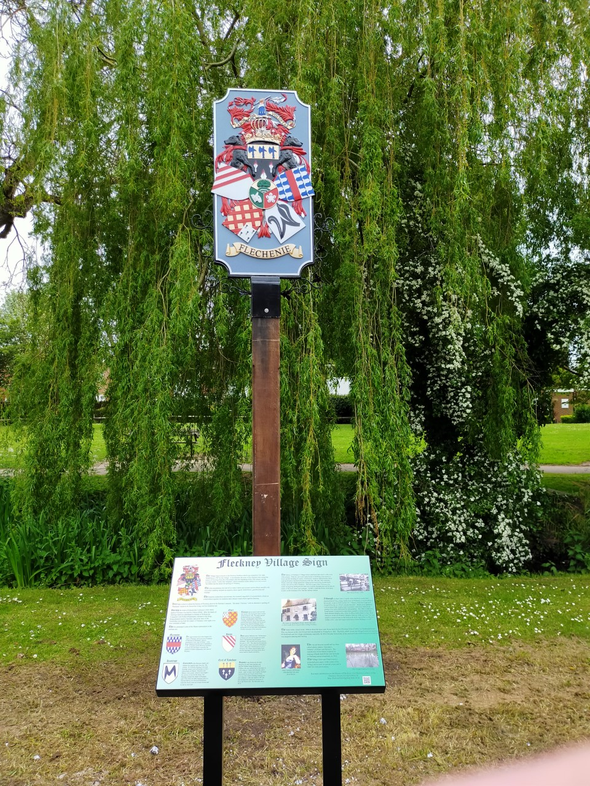
The existing Sports Centre that is due for replacement | The new village sign

