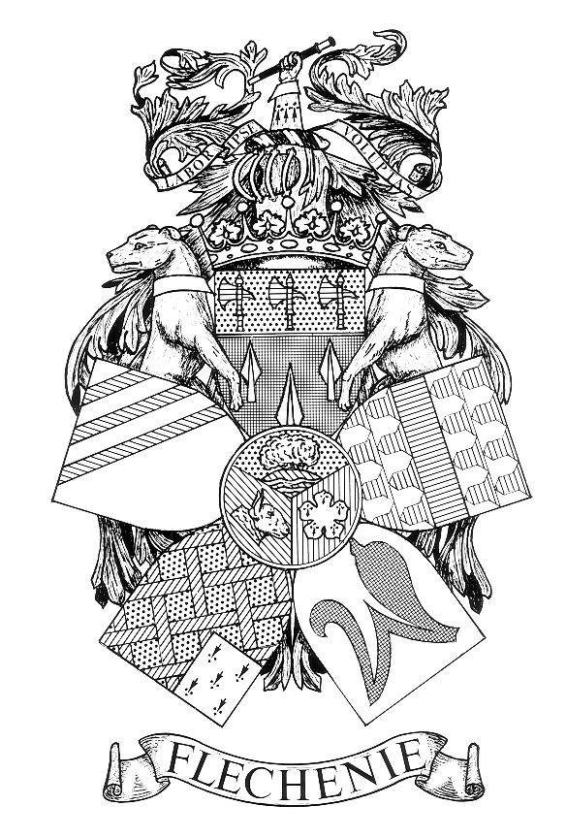 NOTICE OF PARISH COUNCIL MEETING

PARISH OF FLECKNEY

I hereby give notice that a Parish Council Meeting of the Parish Council of the above named Parish will be held at the Sports Centre on Monday 11th December 2023
at 7.00 pm.

All members of the Council are hereby summoned to attend for the purpose of considering and resolving the business to be transacted at the Meeting as set out hereunder.

John Flower
Clerk to the Council
Dated 30 July 2026

AGENDA
- Apologies for Absence.

- Declarations of Interest.
To receive declarations of interest under the Code of Conduct in respect of items on the agenda.

- Dispensation Requests
To receive and approve requests for dispensations from members on matters in which they have a Disclosable Pecuniary Interest.

- Public Participation. (Limited to 15 minutes. The Chairman will adjourn the Meeting during the period of Public Participation).To allow members of the public the opportunity to make representations, ask questions or give evidence about any item of business on the agenda of the Meeting limited to three minutes per person (or one person on behalf of a group of people) about any single item of business.

- Minutes.
To approve and sign the Minutes of the Meeting held on the 13th November 2023
(Enclosure A).

- Matters Arising.
To consider any matters arising from the Minutes of the Meeting held on 13th November 2023. (Matters of report only).

- Accounts.
To receive and approve the:

    - Schedule of amounts for payment (Enclosure B1 to follow).

    - Schedule of receipts for November 2023. (Enclosure B2 to follow).

    - Bank reconciliation report at 30th November 2023. (Enclosure B3 to follow)

- District and County Councillors’ and Police Reports.
To receive reports. (Crime Statistics Enclosure C)

- Correspondence
To receive details of correspondence received since the last Meeting.

- Employees and Chairman’s Reports.
To receive the report of the Street Orderly. (Enclosure D to follow).

- Recreation Committee.
To receive the minutes of the Recreation Committee that met on 27th November 2023 (Enclosure E).

- Planning Applications.
To consider and comment on planning applications received since the last meeting. (Enclosure F).

- Allotment Rents.
To review the rents for the allotment site on Leicester Road to come into effect from 1st April 2024.

- Fleckney Festival.
To consider the request from the Fleckney Festival Committee to hold the following events during 2024 at the Leicester Road Recreation Ground:

    - The main Fleckney Festival event on Saturday 21st September 2024.
(Enclosure G)

    - A Music event on Friday 20th September 2024. (Enclosure G).

    - A Food and Drink Fayre from Friday 31st May to Sunday 2nd June 2024. Enclosure H).

- Application for Financial Assistance.
To consider an application for financial assistance from Mrs. Helen Bentley to help provide a kissing gate to footpath C8 where it meets Leicester Road to limit the access to the land beyond which is currently accessible through an unlocked field gate. (Enclosure I).

- 49 Bus Service – Bus Stop, Leicester Road.
To consider the latest developments.

- Maturing Business Fixed Rate Saver.
To consider renewal terms for the Nationwide Business 1 Year Fixed Rate Saver that matures on 21st December 2023.

- Date of Next Meeting.
Monday 15th January 2024.

Members of the public are welcome to attend but are not permitted to participate except under Item 4 when invited to do so by the Chairman after the Meeting has been adjourned

