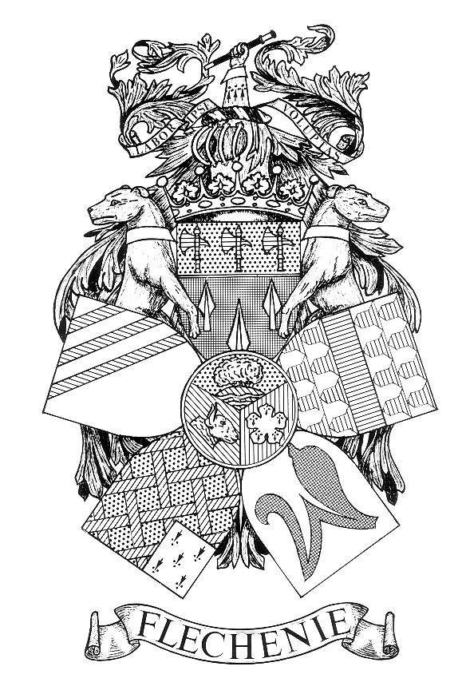 NOTICE OF MEETING

FLECKNEY PARISH COUNCIL

I hereby give notice that a meeting of the Parish Council (Playing Field Charity) will be held at the Village Hall, School Street on Monday 17th April 2023 at the conclusion of the Meeting of the Parish Council.

All members of the Council are hereby summoned to attend for the purpose of considering and resolving the business to be transacted at the Meeting as set out hereunder.

John Flower
Clerk to the Council
Dated 29 July 2026

AGENDA
- Apologies for Absence.

- Declarations of Interest.
To receive declarations of interest under the Code of Conduct in respect of items on the agenda.

- Requests for Dispensations.
To receive and approve requests for dispensations from members on matters in which they have a Disclosable Pecuniary Interest.

- Public Participation. (Limited to 15 minutes. The Chairman will adjourn the Meeting during the period of Public Participation).
To allow members of the public the opportunity to make representations, ask questions or give evidence about any item of business on the agenda of the Meeting limited to three minutes per person (or one person on behalf of a group of people) about any single item of business.

- Minutes.
To approve the Minutes of the Meeting held on the 14th June 2021. (Enclosure A).

- Matters Arising.
To consider any matters arising from the Minutes of the Meetings held on 14th June 2021. (Matters of report only).

- Correspondence.
To receive details of correspondence received.

- Play Equipment.
To consider the recommendation from the Parish Council that a new piece of play equipment is purchased at a cost of £7,659.83 with the Parish Council contributing £3609.09 and the balance of £4,050.74 being met by the Playing Field Charity from the legacy it received.

