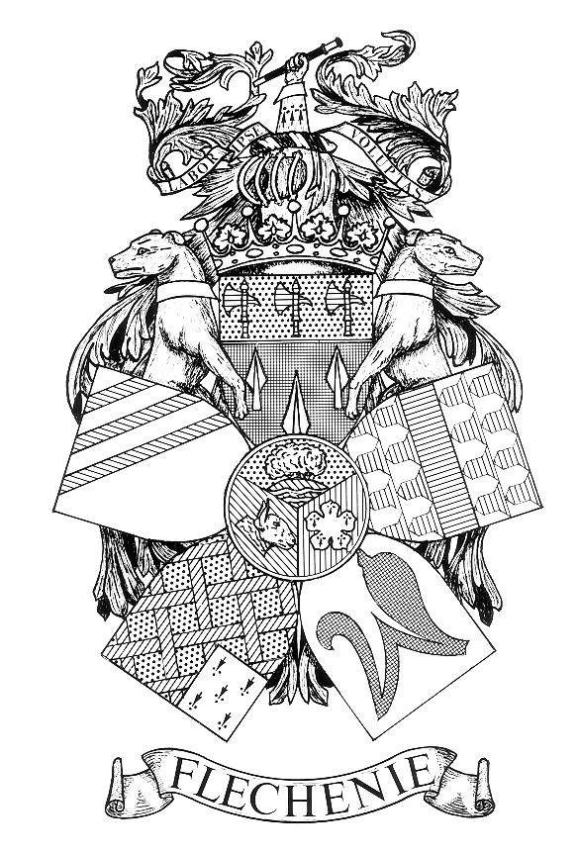 NOTICE OF PARISH COUNCIL MEETING

PARISH OF FLECKNEY

I hereby give notice that a Parish Council Meeting of the Parish Council of the above named Parish will be held at the Sports Centre on Monday 12th February 2024
at 7.00 pm.

All members of the Council are hereby summoned to attend for the purpose of considering and resolving the business to be transacted at the Meeting as set out hereunder.

John Flower
Clerk to the Council
Dated 30 July 2026

AGENDA
- Apologies for Absence.

- Declarations of Interest.
To receive declarations of interest under the Code of Conduct in respect of items on the agenda.

- Dispensation Requests
To receive and approve requests for dispensations from members on matters in which they have a Disclosable Pecuniary Interest.

- Public Participation. (Limited to 15 minutes. The Chairman will adjourn the Meeting during the period of Public Participation).To allow members of the public the opportunity to make representations, ask questions or give evidence about any item of business on the agenda of the Meeting limited to three minutes per person (or one person on behalf of a group of people) about any single item of business.

- Minutes.
To approve and sign the Minutes of the Meeting held on the 15th January 2024
(Enclosure A).

- Matters Arising.
To consider any matters arising from the Minutes of the Meeting held on 15th January 2024. (Matters of report only).

- Accounts.
To receive and approve the:

    - Schedule of amounts for payment (Enclosure B1 to follow).

    - Schedule of receipts for January 2024. (Enclosure B2 to follow).

    - Bank reconciliation report at 31st January 2024. (Enclosure B3 to follow)

- District and County Councillors’ and Police Reports.
To receive reports. (Crime Statistics Enclosure C to follow)

- Correspondence
To receive details of correspondence received since the last Meeting.

- Employees and Chairman’s Reports.
To receive the report of the Street Orderly. (Enclosure D to follow).

- Recreation Committee.
To receive the minutes of the Recreation Committee that met on 29th January 2024.
(Enclosure E).

- Planning Applications.
To consider and comment on planning applications received since the last meeting. (Enclosure F).

- Local Plan Consultation.
To consider and comment on the Harborough DC Local Plan Regulation 18 Consultation. (Enclosure G)
- S106 Grant Application – Village Hall.
To consider a request from the Fleckney Village Hall Committee for support for its application for S106 funding for improvements to the small meeting room at the Village Hall.

- Application for Financial Assistance.
To consider an application for financial assistance from the 1st Fleckney Scouts for its forthcoming trip to the Kandersteg International Scout Centre in Switzerland. (Enclosure H).

- Cricket Bowls Club Netting.
To consider the preferred option for providing netting to protect the Bowls Club premises from cricket balls and the method of financing.

- D Day Celebrations.
To appoint a Working Party to organise and oversee the D Day celebrations on 6th June 2024 and to allocate a budget for the purpose.

- Internal Audit.
To reappoint LRALC as the Council’s Internal Audit provider for the 2023-24 financial year.

- Resignation of Clerk to the Council.
    - The Chairman to report that she had received notice that the Clerk to the Council would be terminating his employment on 5th May 2024.

    - To consider arrangements for appointing a successor.

- Date of Next Meeting.
Monday 11th March 2024

Members of the public are welcome to attend but are not permitted to participate except under Item 4 when invited to do so by the Chairman after the Meeting has been adjourned

